INFANT CURRICULUM (6 weeks – 12 months)
Key Development Areas
- Sensory exploration
- Motor development
- Language exposure
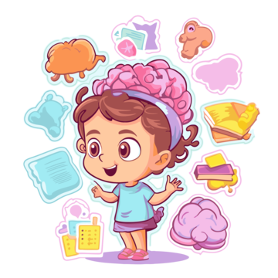
- Emotional bonding & security
- Cognitive & Sensory Development
  - Texture baskets (soft, rough, smooth)
  - Cause-and-effect toys
  - Object permanence games
  - Mirror play
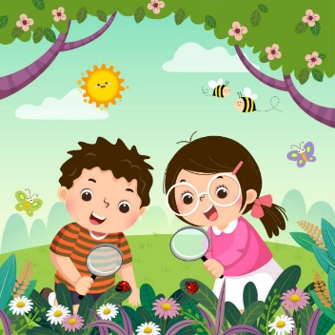
- Science (Exploration-Based)
- Light & shadow play
- Water play (pouring, splashing)
- Nature observation (leaves, flowers)
- Floating & sinking objects


- Early Math Foundations
- Shape recognition
- Size comparison (big/small)
- Counting through songs
- Pattern exposure (colors, textures)

- Language & Communication
- Reading board books daily
- Nursery rhymes & lullabies
- Baby sign language
- Responsive conversation

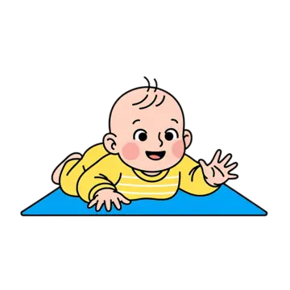
- Physical Development
- Tummy time
- Crawling tunnels
- Grasping toys
- Assisted standing & walking

- Social-Emotional Development
- One-on-one caregiving
- Comfort routines
- Emotional recognition
- Trust-building activities

TODDLER CURRICULUM (1 – 3 years)
Key Focus
- Independence
- Language explosion
- Motor skills
- Social interaction
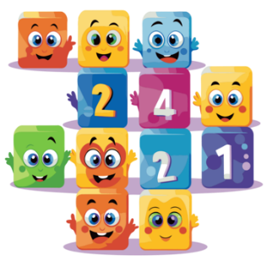
- Mathematics
- Counting 1–10
- Sorting objects by color/shape
- Size sequencing
- Simple patterns


- Science & Discovery
- Planting seeds
- Weather observation
- Animal identification
- Magnet play
- Sink & float experiments

- Creative Arts
- Finger painting
- Play dough
- Music & movement
- Dance with scarves

- simple crafts
- Language & Literacy
- Story time daily
- Picture books
- Vocabulary building
- Songs and rhymes


- Practical Life (Montessori)
- Pouring water
- Spoon transfer
- Cleaning toys
- Dressing frames
- Hand washing routine
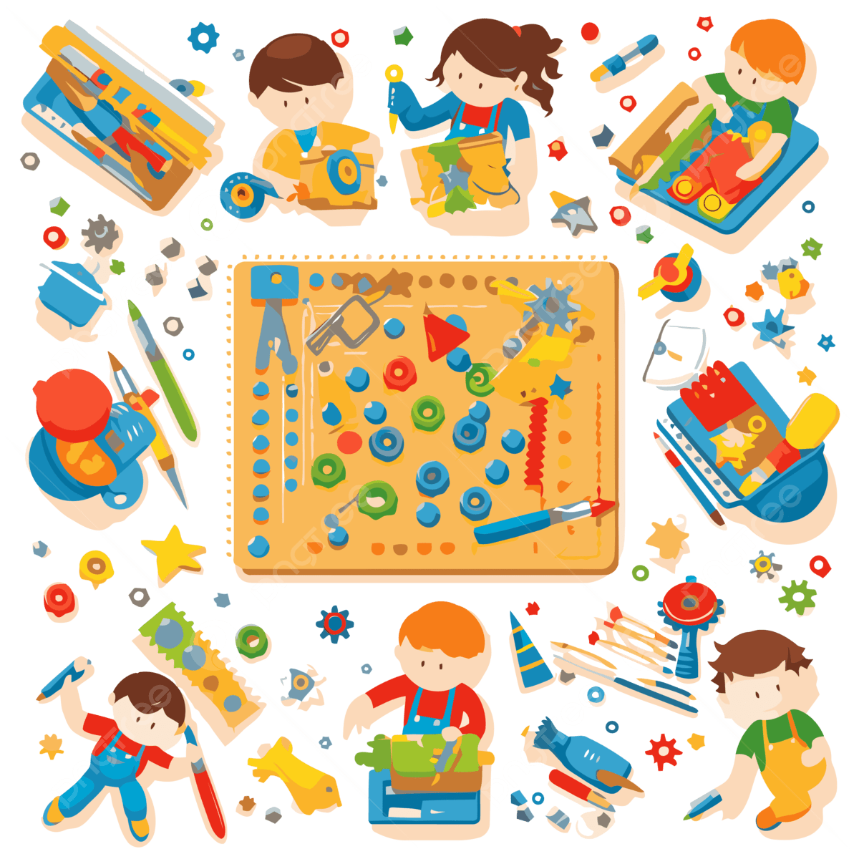
- Gross & Fine Motor Skills
- Climbing structures
- Ball play
- Stacking blocks
- Puzzles

- Scribbling with crayons
- Social-Emotional Learning
- Sharing & turn-taking
- Identifying feelings
- Cooperative play
- Positive behavior guidance
PRESCHOOL CURRICULUM (3 – 5 years)
Key focus
Academic Readiness & Independence
- Mathematics
- Counting 1–50
- Number recognition
- Addition & subtraction
- Simple Multiplication
- Shapes & geometry
- Measurement (length, weight)
- Patterns & sequencing

- Science

- Life cycles (plants, insects)
- Weather & seasons
- Simple experiments
- Earth science (water, soil)
- STEM activities
- Nature walks & observation journals


- Language & Literacy
- Phonics & letter sounds
- Sight words
- Writing name & simple words
- Story retelling
- Rhyming words
- Pre-reading skills


- Cultural & Geography Studies
- Maps & globes
- Community helpers
- Festivals & traditions
- Diversity & inclusion
- World animals

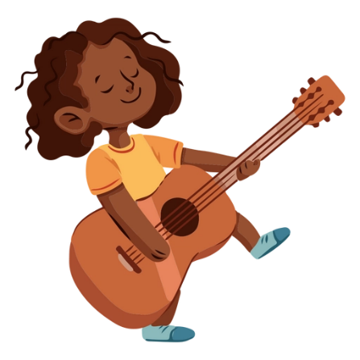
- Art, Music & Creativity
- Painting & drawing
- Cutting & pasting
- Music instruments
- Drama & role play
- Seasonal crafts

- Practical Life & Independence
- Classroom jobs
- Food preparation
- Care of environment
- Problem solving
- Time management

- Social-Emotional Learning
- Conflict resolution
- Leadership skills
- Emotional regulation
- Respect & kindness
- Confidence building

- Physical Development
- Yoga for kids
- Obstacle courses
- Outdoor games
- Fine motor strengthening
- Sports basics

Assessment & Progress Tracking


- Visible developmental progress
- Observational notes
- Worksheet review

Outcome
Children leave our program:
- Confident
- Curious
- Independent
- Kindergarten-ready

